**One Cognizant**

**Visual Studio Project Template Document**

Version 0.1 – Initial Draft

|  |  |  |  |
| --- | --- | --- | --- |
|  | **Prepared By / Last Updated By** | **Reviewed By** | **Approved By** |
| **Name** | Gopalakrishnan (Microsoft) |  |  |
| **Role** | Consultant |  |  |
| **Date** | 29-Jun-11 |  |  |

Contents

1 Introduction 3

2 One-C Visual Studio Project Template 3

2.1 Visual Studio Project Structure 3

2.2 One-C Assembly References 4

2.3 Common Folder 4

2.4 Database Scripts Folder 4

2.5 Docs Folder 4

2.6 Test Launch Pages Folder 4

2.7 Pages Folder 4

2.8 Resources Folder 5

2.9 Test Cases Folder 5

2.10 User Controls Folder 5

2.11 Web.Config 5

2.12 OneC.snk 5

3 One-C Visual Studio ITEM Template 5

3.1 OneC Web Form 5

# 1 Introduction

This document explains the One-C Visual Studio project template structure.

# 2 One-C Visual Studio Project Template

The following section explains in detail about the Visual Studio project structure.

## 2.1 Visual Studio Project Structure

The following is the structure of the Visual Studio project.

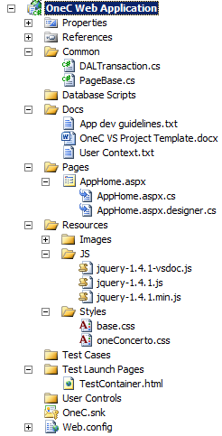

## 2.2 One-C Assembly References

The VS project template references the following 4 dlls.

1. CTS.OneCognizant.Platform.CoreServices.dll.
2. CTS.OneC.Platform.CoreServices.FormRedirectionUrl.dll
3. CTS.OneC.PlatForm.CoreServices.FormUrl_BLL.dll
4. CTS.OneC.PlatForm.CoreServices.FormUrl_DAL.dll

## 2.3 Common Folder

The Common folder contains the two files:

1. DALTransaction class: This contains basic data access code with a Connection String property, a sample data access method and Dispose methods.
2. PageBase class: This class inherits System.Web.UI.Page class. The AppHome.aspx and the OneC Web Form item template inherit the PageBase class. Developers can use this class to provide common and abstracted functionality to their web pages in their applications.

## 2.4 Database Scripts Folder

Use this folder to hold your back-end script files.

## 2.5 Docs Folder

This folder contains How-To documents, sample code and links to other guidelines and references. This folder has two files:

1. App dev guidelines contains links to detailed How-To documents stored in a SharePoint site.
2. User Context contains a sample code that explains how to use the UserContext class.
3. OneC VS Project Template – This file.
4. URL Redirection contains a sample code that explains how to use the RedirectionUrl class.

## 2.6 Test Launch Pages Folder

This folder contains an HTML file called ‘TestContainer.html’ used to test your application. The HTML file has an IFRAME, set to specific width and height. By default the URL of the IFRAME is set to /Pages/AppHome.aspx folder. You can launch this page to see how your application looks like within the IFRAME and whether all of your pages confirm to the same height and width specified in the guidelines document.

## 2.7 Pages Folder

The Pages folder will have all the ASPX files used by your application. By default, the template will provide AppHome.aspx to be used as the default page of your project, but you are free to change this one. The AppHome.aspx inherits from PageBase class.

The AppHome.aspx contains a DIV (called divMain) which has a specified width and height. You must not change the values of those attributes and should not remove them either. However, you are free to change the ID value or any other attributes, including the back-ground color.

The code-behind will have the ‘CTS.OneCognizant.Platform.CoreServices’ namespace included.

The AppHome.aspx also contains the sample reference code for using the User Context to get the current user’s profile information. For more information on the User Context, please refer to the guidelines document.

## 2.8 Resources Folder

The Resources folder contains the following folders:

1. Images: Contains all the images for your application. By default, this folder will have a set of images that is available for the developers to use.
2. JS: This folder is to hold all the java script files for the application. By default, this folder will have JQuery files.
3. Styles: This folder holds all the CSS files used by the application. By default, this folder will contain 2 CSS files – base.cs and oneConcerto.cs

## 2.9 Test Cases Folder

The Test Cases folder is for having all the test cases of your application.

## 2.10 User Controls Folder

The User Controls folder is used to hold all the ASCX files or custom web controls.

## 2.11 Web.Config

The Web.Config file contains one <connectionString> element by default with the key “ConnectionString”. No value is provided and it is up to the developer to provide the connection string value. The same key is also used in the DALTransaction class. If you are changing the key in the web.config file, then make sure that the old key name is replaced with this new key in the DALTransaction class also.

## 2.12 OneC.snk

The project template contains a strong name key file and the web application by default produces a strong named assembly.

# 3 One-C Visual Studio ITEM Template

The following section explains in detail about the Visual Studio project structure.

## 3.1 OneC Web Form

The OneC Web Form item template is a web form that is similar to AppHome.aspx. As and when you need to create additional web pages in your OneC web application, you can create instances of this form.

This form, like the AppHome.aspx, will contain a DIV with requisite height and width set. The code-behind will have the ‘CTS.OneCognizant.Platform.CoreServices’ namespace included.

However, it will not contain the sample User Context reference code.

To create a new OneC Web Form, from your OneC Web Application in Visual Studio, right-click on the Pages folder and select “Add -> New Item” menu.

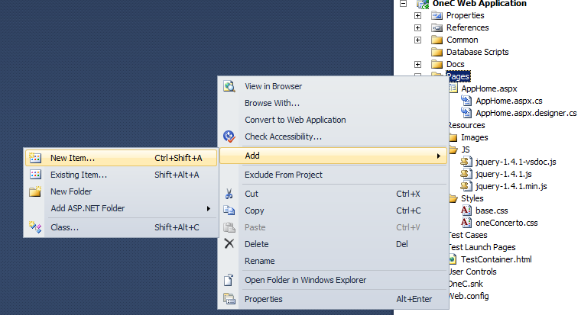

Expand “Visual C#” and click on “OneC” category.

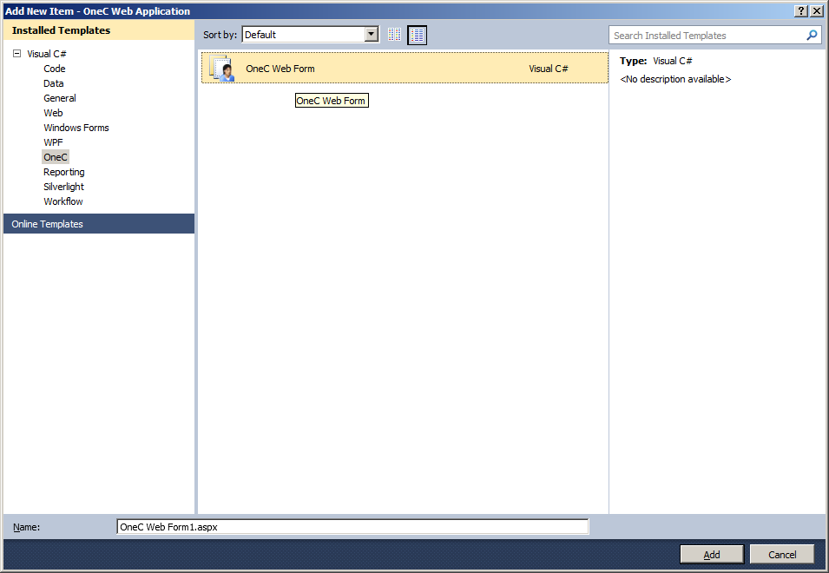

Select the OneC Web Form template to create a new page.